How To Use Python Interpreter

Starting the python interpreter

Task:

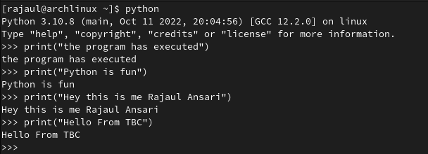

Using Command History

Task:

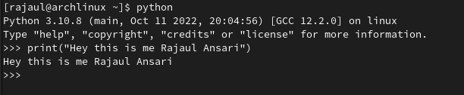

Getting Help

Task: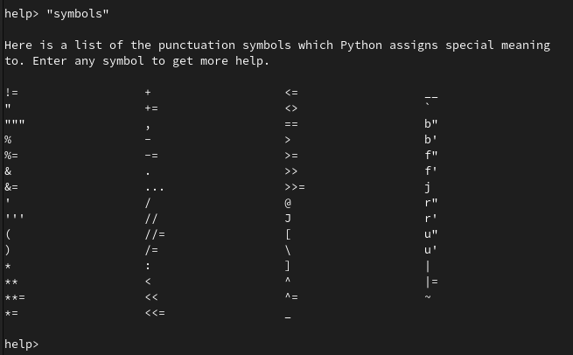

Task:

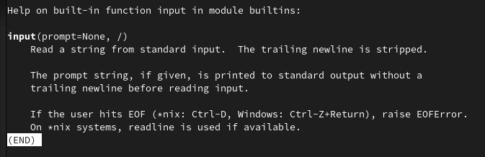

Quitting the Python Interpreter

Task: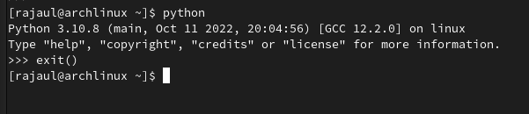

Entering Basic Expressions

Task: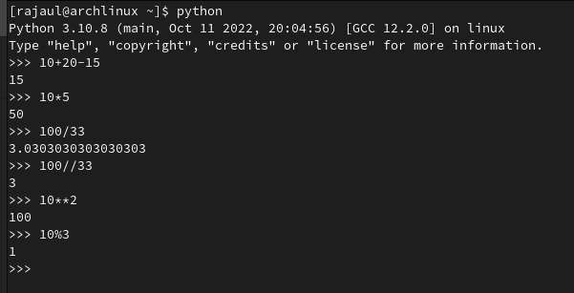

​Operator Precedence

Task: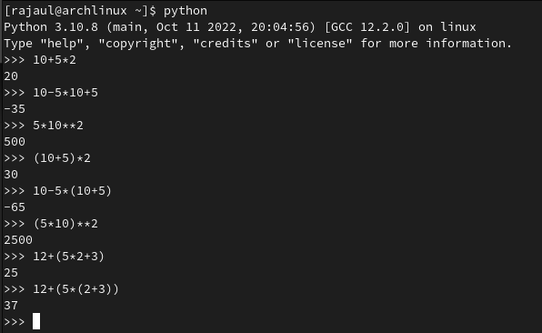

Errors:

* Task: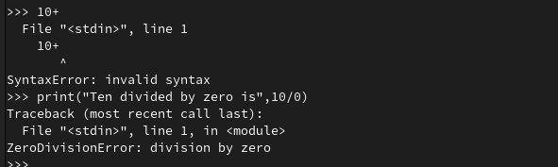

Key Terminology

Task:

* Source code: Source code is the fundamental component of a computer program that is created by a programmer.
* Machine Code: Machine code is a strictly numerical language which is designed to run as fast as possible.
* Interpreter: A computer program that translates andexecutes, statement by statement, a program written in ahigh-level language
* Compiler: A compiler is a special program that translates a programming language's source code into machine code, bytecode or another programming language.
* 2GL,3GL,4GL: Second Generation Programming languages, Third Generation Programming languages, Fourth Generation Programming languages respectively.
* Executable: A file or program that is able to be run by a computer.
* Expressions: An expression is a combination of values and functions that are combined and interpreted by the compiler to create a new value.
* Operators and Operands: Operators are the symbols and Operands are the numbers.
* Syntax Errors: Syntax errors are mistakes in the source code, such as spelling and punctuation errors, incorrect labels, and so on, which cause an error message to be generated by the compiler.
* Logical Errors: A logical error in a program is an error where the instructions given in the program do not accomplish the intended goal.